Technical Report
- Problem Recap & SMC Context

Smart Safety and Assistance System for Sanitation Workers of Solapur Municipal Corporation

- Brief problem description
Solapur Municipal Corporation faces a serious sanitation safety challenge in which hazardous sewer and manhole operations still expose sanitation workers to toxic gases, oxygen-deficient confined spaces, flooding risk, infection, and structural instability. Although mechanization initiatives, PPE distribution, and legal safeguards exist, field operations still suffer from blind entry risk, insufficient real-time monitoring, weak digital traceability, and incomplete visibility for municipal decision-makers. As a result, hazardous manual exposure is not fully prevented, machine utilization is not optimally enforced, and emergency response remains more reactive than proactive.

The Phase 1 problem definition established that SMC lacks an integrated, real-time, technology-enabled safety, monitoring, and assistance system that can completely reduce unsafe manual exposure, detect gas-related danger before or during work, improve supervisor visibility, enforce digital authorization, and strengthen worker dignity through accountable sanitation governance. Our Phase 2 prototype directly builds on that foundation through a practical pilot-scale implementation called Veer Suraksha Grid, designed as a bilingual, map-centric municipal operating platform connecting field workers, machines, sensor feeds, approvals, and command visibility into one coordinated system.

- Current challenges in SMC related to this problem
SMC manages sanitation through a decentralized structure of eight zonal offices, while the underground drainage network has expanded to about 246.14 km and further growth is planned. At the same time, nearly 49% of the population still depends on on-site sanitation, which increases the diversity and complexity of sanitation operations.
A major field challenge is accessibility. More than 220 slum settlements have narrow lanes that restrict the movement of large mechanized cleaning vehicles. Although SMC has jetting, rodding, sludge-removal, and septic emptying machines, and has also been allocated a robotic cleaning unit, fleet reach and practical deployment remain limited in several areas. This creates continued dependence on manual fallback in difficult locations.
Another major gap is the absence of real-time digital safety monitoring. There is no documented operational use of IoT-based gas sensing inside manholes, so workers may still depend on unsafe informal methods to judge air safety. This leaves them vulnerable to toxic gas exposure and suffocation risk.
Operational visibility is also fragmented. SMC already has grievance channels, GIS systems, and ICCC infrastructure, but it does not yet have a unified sanitation safety layer that connects complaint intake, asset history, zone risk, machine availability, pre-entry inspection, digital approval, live monitoring, and incident logging into one workflow. As a result, machine-first enforcement, supervisor control, and full traceability remain weak.
In addition, any practical system for SMC must support Marathi language usage, low digital literacy, underground connectivity challenges, wet and corrosive field conditions, and budget-conscious deployment. These realities make technical feasibility and on-field usability essential design requirements.
- Objectives & Implementation Mapping
Sr No. | Objective | Implemented (Yes/No) | Evidence (Module names)
1 | Reduce unauthorized or blind manual sewer entry through monitored workflow | Yes | VeerPass, VeerProbe, VeerRisk, VeerVision, Commander/Admin Dashboard
2 | Support real-time hazard monitoring of gas and oxygen levels during operations | Yes | VeerGuard, VeerProbe, VeerEdge, InfluxDB telemetry layer, Dashboard
3 | Detect toxic/explosive gas risk and trigger fast alerts | Yes | VeerGuard, VeerProbe, VeerEdge, VeerRisk, Dashboard Alerts
4 | Enable distress alert and emergency escalation | Yes | VeerGuard, Worker SOS module, Communication module, Commander/Admin Dashboard, VeerBlackBox
5 | Provide centralized visibility for high-risk sanitation tasks | Yes | SwachhCommander Dashboard, Solapur Map View, VeerRegistry, Grievance Integration
6 | Increase mechanized equipment usage and reduce unnecessary manual fallback | Yes | FleetEye, VeerPass, VeerRisk, VeerCrawler
7 | Ensure digital authorization logging for manual entry decisions | Yes | VeerPass, Firebase records, VeerBlackBox
8 | Support pre-entry inspection before human intervention | Yes | VeerProbe, VeerCrawler, VeerVision
9 | Maintain incident timeline for audit and replay | Yes | VeerBlackBox, Dashboard, Firebase + InfluxDB integration
10 | Improve preventive and risk-based planning of sanitation operations | Yes | VeerPlan, VeerRegistry, VeerRisk, Grievance Integration
11 | Enable complaint-linked task generation and tracking | Yes | Grievance Integration, VeerRegistry, VeerPlan, SwachhCommander Dashboard
12 | Support AI-assisted hazard understanding for better approval decisions | Yes | VeerVision, VeerRisk, VeerPass

- Constraints & Handling Mapping
Sr No. | Constraint | Type | How Addressed
1 | Compliance with manual scavenging and worker safety regulations | Legal / Operational | The prototype uses VeerPass to enforce digital approval before manual entry and records all decisions in VeerBlackBox, reducing informal unsafe descent.
2 | Wet, corrosive, and hazardous sewer environment | Technical / Environmental | The field hardware is designed in such a way that it remains aligned to deployable rugged device assumptions such as sewer-safe wearable and probe usage.
3 | Narrow slum lanes restricting large machine access | Operational / Spatial | The system includes VeerCrawler for portable inspection support and uses FleetEye to allocate available machines while allowing conditional fallback logic where access is limited.
4 | Underground connectivity and signal reliability challenges | Technical | VeerEdge is designed as the field communication layer to relay telemetry, buffer temporary outages, and support reliable data transfer from field devices to the platform.
5 | Budget constraints for large-scale deployment | Financial | The prototype design addresses financial limitations by leveraging cost-effective technologies, such as Firebase and InfluxDB Cloud, to demonstrate core functionality. This strategy avoids expensive field hardware during the initial phase, thereby strengthening the project's feasibility for scalable, phased deployment.
6 | Need to integrate with existing ICCC systems instead of creating separate infrastructure | Technical / Institutional | SwachhCommander is designed as an ICCC-extension style dashboard and the system architecture is framed as an added safety layer over existing grievance, GIS, and command infrastructure.
7 | Minimal additional manpower requirement | Operational | The prototype merges Supervisor/Admin and ICCC command functions into one Commander/Admin role, reducing operational complexity while preserving approval and monitoring logic.
8 | Limited digital literacy among frontline workers | Human / Usability | The worker interface is designed as Marathi-first, simple, task-driven, and alert-oriented with minimal complexity, direct status visibility, and one-tap SOS communication.
9 | Need for continuous monitoring and quick alerting | Functional / Safety | VeerGuard, VeerProbe, InfluxDB telemetry, dashboard alerts, and SOS workflows together support real-time visibility and emergency escalation logic.
10 | Need for higher machine utilization and reduced manual fallback | Operational / Safety | FleetEye tracks machine availability and VeerPass checks machine-attempt logic before allowing manual fallback, especially in medium- and high-risk tasks.
11 | Need for traceability and post-incident accountability | Governance / Safety | VeerBlackBox stores event timeline, approvals, alerts, and incident flow, while Firebase and InfluxDB together support both operational records and telemetry history.

- System Architecture Subsystems

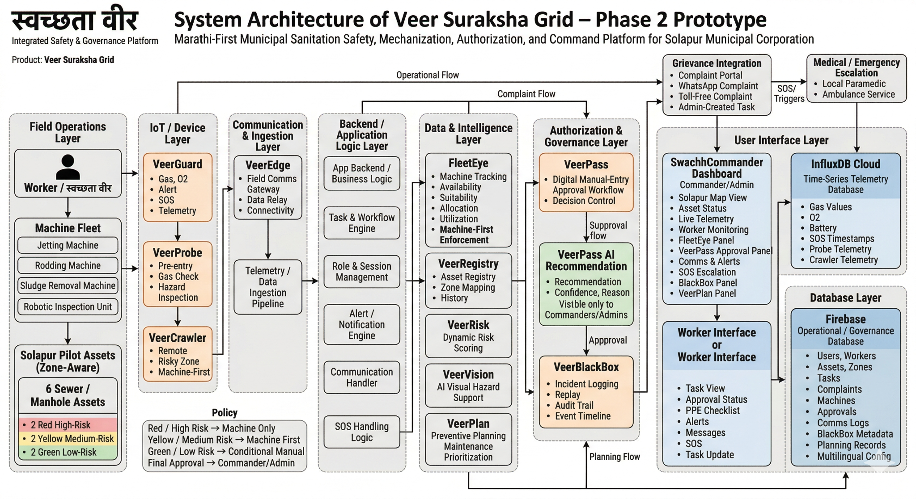Fig : Architecture Diagram

System Overview
Veer Suraksha Grid is designed as a field-to-command municipal sanitation safety platform with two user sides: Worker / स्वच्छता वीर and Commander/Admin. The system connects field devices, asset records, machine status, approval workflow, communication, and emergency handling into one integrated architecture
- Data Flow .
Field data from VeerGuard, VeerProbe, and VeerCrawler moves through VeerEdge to the platform.
Time-series safety data is stored in InfluxDB Cloud, while operational data such as users, assets, tasks, approvals, machine records, communication logs, and incident records are stored in Firebase.
The backend processes this data through VeerRisk, FleetEye, VeerVision, VeerPass, VeerPlan, and VeerBlackBox, then sends the result to the Worker interface and SwachhCommander dashboard.

User Flow
A task enters the system through complaint, admin entry, or planned maintenance.
The asset is identified through VeerRegistry and checked against its zone type.
Field inputs and machine status are processed.
Commander/Admin reviews the request through VeerPass and takes the final decision.
The worker receives task status, instructions, alerts, or SOS support through the Worker interface.
All important actions are logged in VeerBlackBox.

Key Components
- VeerGuard – worker safety wearable
- VeerProbe – pre-entry inspection kit
- VeerCrawler – remote robotic inspection unit
- VeerEdge – field communication gateway
- FleetEye – machine tracking and machine-first enforcement
- VeerRegistry – sewer/manhole asset registry
- VeerRisk – dynamic risk scoring engine
- VeerVision – AI-based visual hazard support
- VeerPlan – preventive planning engine
- VeerPass – manual-entry authorization system
- VeerBlackBox – incident logging and replay system
- SwachhCommander Dashboard – central municipal command interface
- Grievance Integration – complaint-to-task workflow integration

- Subsystems

Sr No. | Subsystem Name | Function (one or more) | Input | Output | Technology Used
1 | VeerGuard | - Worker safety monitoring  - Gas sensing  - SOS alert | Gas values, O₂ level, SOS trigger, device status | Live telemetry, safety alerts, SOS event | IOT, InfluxDB Cloud, Firebase
2 | VeerProbe | - Pre-entry inspection  - Hazard checking | Gas readings, inspection observations, asset details | Inspection result, hazard input | IOT, InfluxDB Cloud, Firebase
3 | VeerCrawler | - Remote inspection in risky zones | Target asset, inspection command, visual feed/status | Remote inspection result, hazard support | IOT, Firebase
4 | VeerEdge | - Field-to-platform communication support | Sensor/device data, event signals | Relayed and synchronized data | Backend/App Logic, IOT
5 | FleetEye | - Machine tracking  - Allocation  - Machine-first enforcement | Machine inventory, machine status, task type, risk context | Machine availability, allocation status, machine-attempt check | Backend/App Logic, Firebase
6 | VeerRegistry | - Digital record of sewer/manhole assets | Asset ID, location, zone type, history, complaint/task link | Asset profile, map-linked asset data | Firebase DB
7 | VeerRisk | - Dynamic risk scoring  - Task risk evaluation | Zone type, telemetry, inspection data, asset history, task input | Risk score, risk class, route recommendation | Backend/App Logic, Firebase, InfluxDB Cloud
8 | VeerVision | - AI-based visual hazard detection | Inspection visuals, image/video input | Hazard flag, anomaly indication | AI/ML, Backend Logic
9 | VeerPlan | - Preventive planning  - Maintenance prioritization | Asset history, complaint trends, risk data | Preventive task suggestions, planning priorities | Firebase, Backend/App Logic
10 | VeerPass | - Manual-entry authorization  - Approval workflow | Task request, risk score, inspection status, machine availability, PPE status | Approve/reject/hold decision, authorization log | Firebase, Backend/App Logic
11 | VeerBlackBox | - Incident logging  - Replay  - Audit trail | Alerts, approvals, SOS events, task actions, event timeline | Incident history, replay log, audit record | Firebase, InfluxDB Cloud
12 | SwachhCommander Dashboard | - Central monitoring  - Control  - Decision support | Worker data, asset data, telemetry, machine data, approval requests | Live dashboard view, alerts, approvals, map control | Web Dashboard, Firebase, InfluxDB Cloud
13 | Grievance Integration | - Complaint intake  - Workflow triggering | Portal complaints, WhatsApp complaints, toll-free inputs, admin tasks | Complaint-linked task generation, workflow trigger | WhatsApp BOT,Firebase, Backend/App Logic

- Subsystem Interaction Matrix

Sr No. | From Subsystem | To Subsystem | Type of Interaction | Purpose
1 | VeerGuard | VeerEdge | Telemetry transfer | Sends live gas, O₂, and SOS data
2 | VeerProbe | VeerEdge | Inspection data transfer | Sends pre-entry inspection data
3 | VeerCrawler | VeerEdge | Status/data transfer | Sends remote inspection data
4 | VeerEdge | InfluxDB Cloud | Data upload | Stores live sensor telemetry
5 | InfluxDB Cloud | VeerRisk | Telemetry access | Provides live values for risk scoring
6 | VeerRegistry | VeerRisk | Context sharing | Provides asset, zone, and history data
7 | Grievance Integration | VeerRegistry | Complaint linkage | Maps complaint to asset
8 | Grievance Integration | VeerPlan | Complaint feed | Supports task planning
9 | VeerVision | VeerRisk | Hazard input | Adds visual hazard flags
10 | FleetEye | VeerPass | Machine status input | Provides machine availability and suitability
11 | VeerRisk | VeerPass | Risk input | Provides risk score for approval
12 | VeerProbe | VeerPass | Inspection input | Supports manual-entry decision
13 | VeerPass | SwachhCommander Dashboard | Workflow update | Shows approval status
14 | SwachhCommander Dashboard | VeerPass | Final decision | Admin approves or rejects entry
15 | VeerPass | Worker Interface | Status update | Sends approval result to worker
16 | SwachhCommander Dashboard | Worker Interface | Alert/communication | Sends instructions and alerts
17 | Worker Interface | SwachhCommander Dashboard | Message/SOS | Sends updates and SOS
18 | Worker Interface | Emergency Escalation | Emergency trigger | Triggers medical support
19 | SwachhCommander Dashboard | Emergency Escalation | Escalation control | Coordinates emergency response
20 | VeerGuard | VeerBlackBox | Event logging | Stores alerts and distress events
21 | VeerPass | VeerBlackBox | Decision logging | Stores approval records
22 | SwachhCommander Dashboard | VeerBlackBox | Incident review | Accesses replay and audit logs
23 | VeerRisk | VeerPlan | Planning input | Shares risk trends for planning
24 | VeerRegistry | SwachhCommander Dashboard | Asset visibility | Supplies map-linked asset data
25 | FleetEye | SwachhCommander Dashboard | Fleet visibility | Supplies machine status
26 | Firebase | SwachhCommander Dashboard | Data access | Provides app and governance records
27 | Firebase | Worker Interface | Data access | Provides worker task and status data

- Prototype Description

Workflow
The prototype works as a connected municipal safety workflow with two interfaces: Worker / स्वच्छता वीर and Commander/Admin. The worker side supports task execution, safety status, communication, and SOS. The Commander/Admin side supports map monitoring, risk review, machine-first enforcement, approval control, alerts, and incident tracking.

Step-by-Step Explanation of System Working
Step 1: Input
A task enters the system through a complaint, scheduled maintenance, admin-created task, or operational trigger. It is linked to one of the six mapped sewer/manhole assets. Each asset already belongs to a risk zone: Red, Yellow, or Green.
Step 2: Asset and Zone Identification
The system fetches asset details from VeerRegistry, including location, zone, history, and task context. This sets the base operating rule for that asset.
Step 3: Field Data Capture
VeerGuard, VeerProbe, and VeerCrawler provide worker safety data, pre-entry inspection data, and remote inspection data. These become the live inputs for decision-making.
Step 4: Processing
The system processes asset context, inspection data, live readings, and machine availability. VeerRisk calculates task risk, FleetEye checks machine availability, VeerVision supports hazard review, and VeerPass prepares the approval workflow.
Step 5: Admin Review and Decision
The Commander/Admin dashboard shows the Solapur map, task details, worker status, machine status, and approval request. For manual entry, the admin reviews VeerPass and gives the final approve, reject, or hold decision.
Step 6: Output to Worker
The final status is sent to the worker interface. The worker sees task details, risk status, approval result, checklist, and instructions.
Step 7: Monitoring and Communication
During operation, the system continues live monitoring. The worker and Commander/Admin can exchange alerts, updates, and messages through the platform.
Step 8: Emergency Handling
If SOS is triggered, the dashboard shows an emergency alert, VeerBlackBox logs the event, and the medical escalation workflow starts.
Step 9: Logging and Closure
After completion, approvals, alerts, communication, and incidents are stored in VeerBlackBox. Asset and task history are updated for future planning.

Input → Processing → Output
Input:
Task request, asset details, zone category, inspection inputs, gas/oxygen readings, machine availability, worker updates, complaint/task information
Processing:
Asset lookup, risk scoring, machine-first check, hazard review, approval workflow, communication and emergency handling
Output:
Approval/rejection/hold decision, worker instructions, live alerts, map-based status visibility, emergency escalation, incident log, updated task status
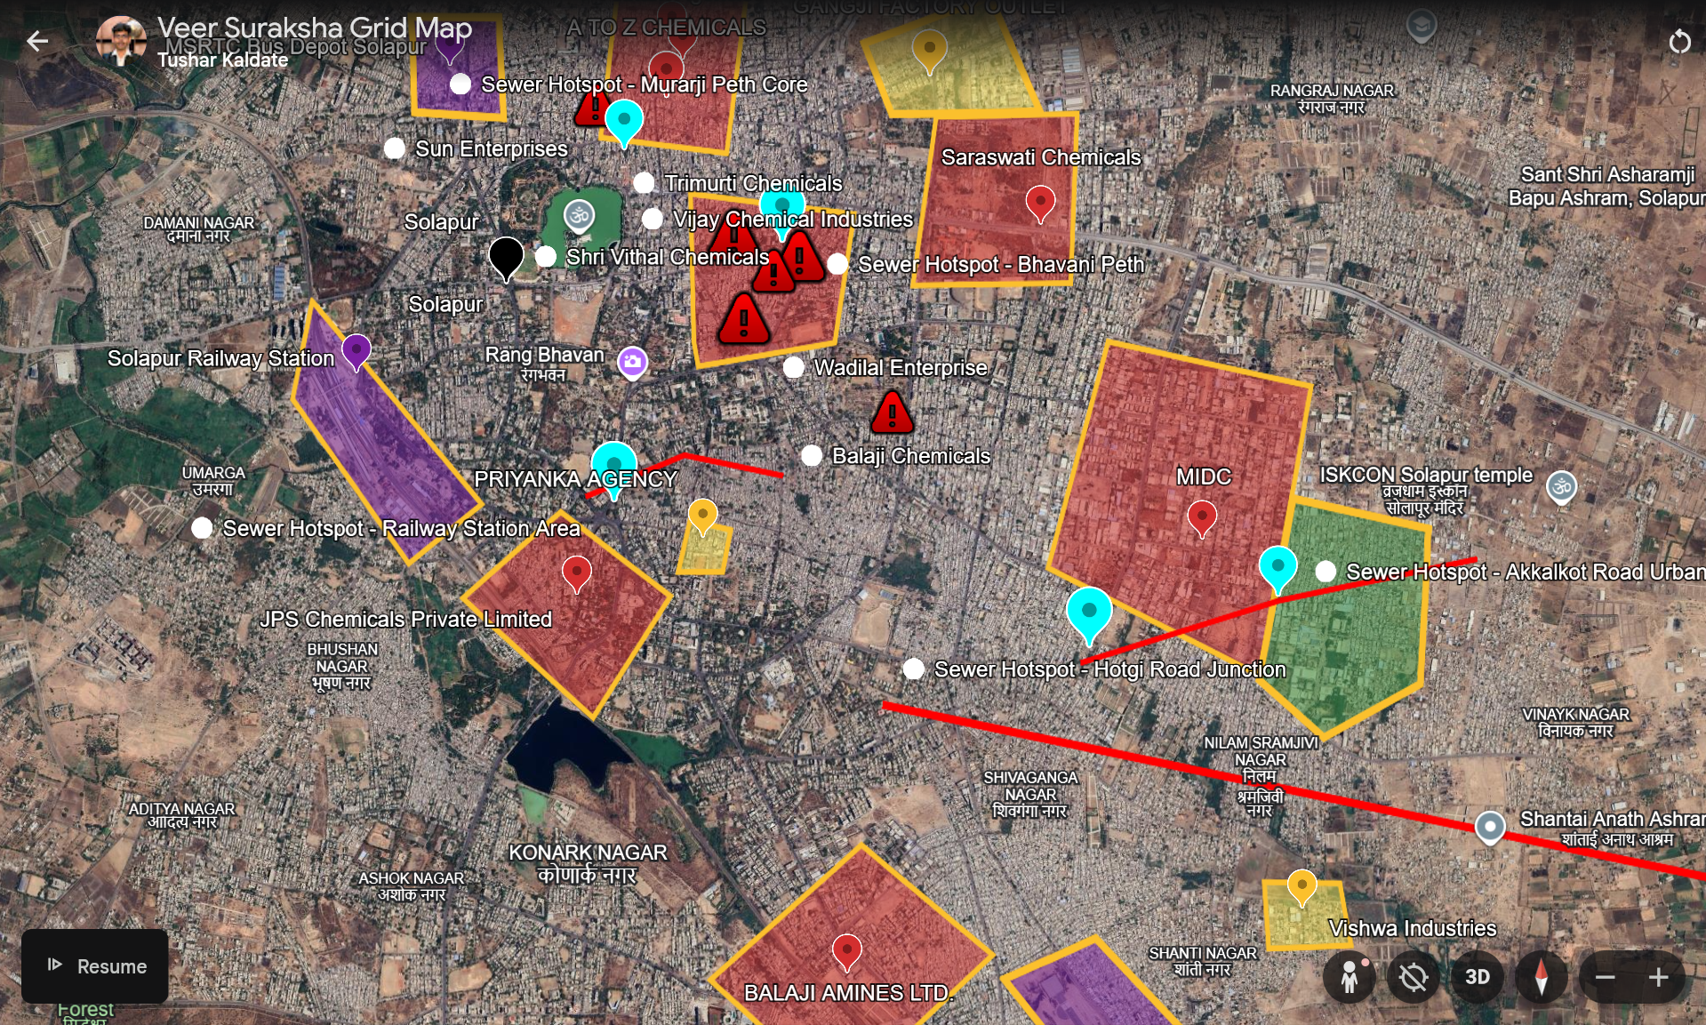
7.1 : Solapur City - Classified into zones (RED - Danger , Yellow - Industrial , Green - safe)

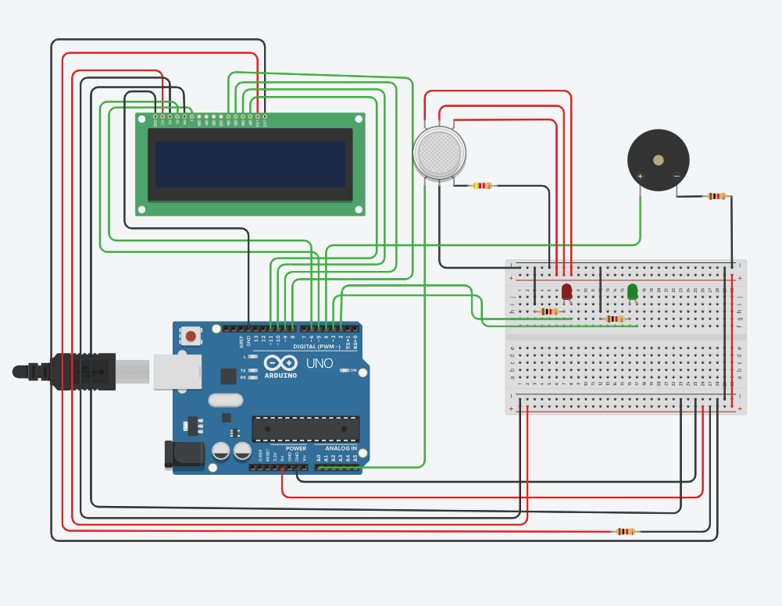
7.2 : IOT - Veer Guard
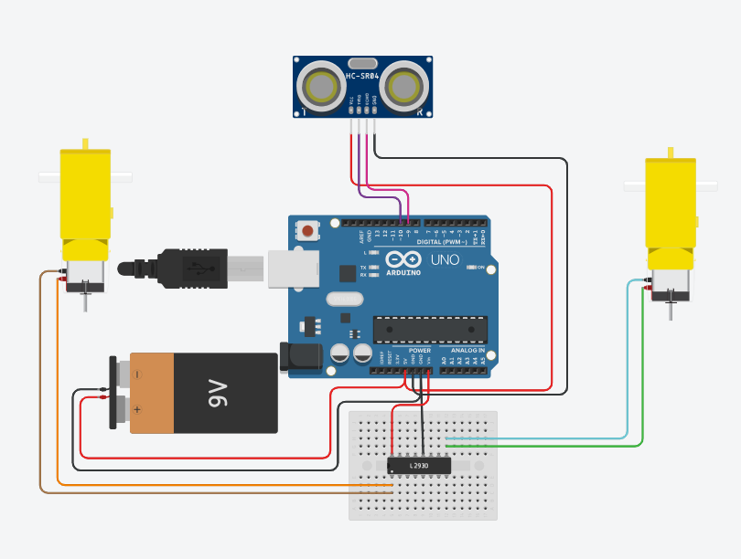
7.3 : IOT - Veer Crawler
- Technology Stack & Tools

Sr No. | Layer | Technology Used | Justification
1 | Frontend | HTML, CSS, JavaScript, | Used to build the worker interface and Commander/Admin dashboard.
2 | UI Framework / Styling | Bootstrap, Custom CSS | Used to create a responsive, municipal-style, Marathi-first interface.
3 | Backend | Node.js, Express.js | Used to manage APIs, business logic, approval workflow, risk processing, and system integration.
4 | Database 1 | Firebase | Used to store users, workers, assets, tasks, approvals, machine records, communication logs, and governance data.
5 | Database 2 | InfluxDB Cloud | Used to store time-series telemetry such as gas values, O₂, SOS, and device data.
6 | AI/ML | AI-assisted logic / rule-based decision support | Used in VeerVision for hazard interpretation and in VeerPass for admin-side recommendation support.
7 | IoT / Device Layer | ESP32 logic, gas sensor integration, wearable/probe/crawler device layer | Used to capture worker safety data, pre-entry inspection data, and remote inspection data from VeerGuard, VeerProbe, and VeerCrawler.
8 | Mapping | Leaflet / map integration | Used to display the Solapur map with 6 color-coded sewer/manhole assets.
9 | Communication | Firebase messaging logic / app communication layer | Used to support worker-admin communication, alerts, and SOS flow.
10 | Hosting / Deployment | Firebase Hosting | Used to deploy the prototype web application online.
11 | Tools / Platforms | VS Code, Git, GitHub | Used for development, version control, and collaboration.

- Innovation Highlights

- Integrated platform: Combines safety monitoring, machine-first enforcement, approval control, communication, SOS, and municipal command in one system.
- Zone-based logic: Uses Red, Yellow, and Green risk zones with different operating rules instead of one common workflow.
- FleetEye innovation: Checks machine availability and suitability before manual fallback, not just machine tracking
- VeerPass control: Makes manual entry a digital, rule-based approval process instead of an informal field decision.
- AI-assisted support: VeerVision and VeerPass provide admin-side hazard and approval support using data-driven logic.
- Worker-centered safety: Supports two-way communication, live alerts, and SOS-based emergency escalation.
- Map-based command view: Shows six Solapur assets with linked risk, task, worker, and machine visibility.
- Better than existing approach: Replaces fragmented manual monitoring with one connected, accountable workflow.
- Data-driven operations: Uses risk scoring, approval logic, incident logging, and preventive planning for smarter decisions.

- Results / Demonstration
- Prototype Link : https://veer-suraksha-grid.netlify.app/

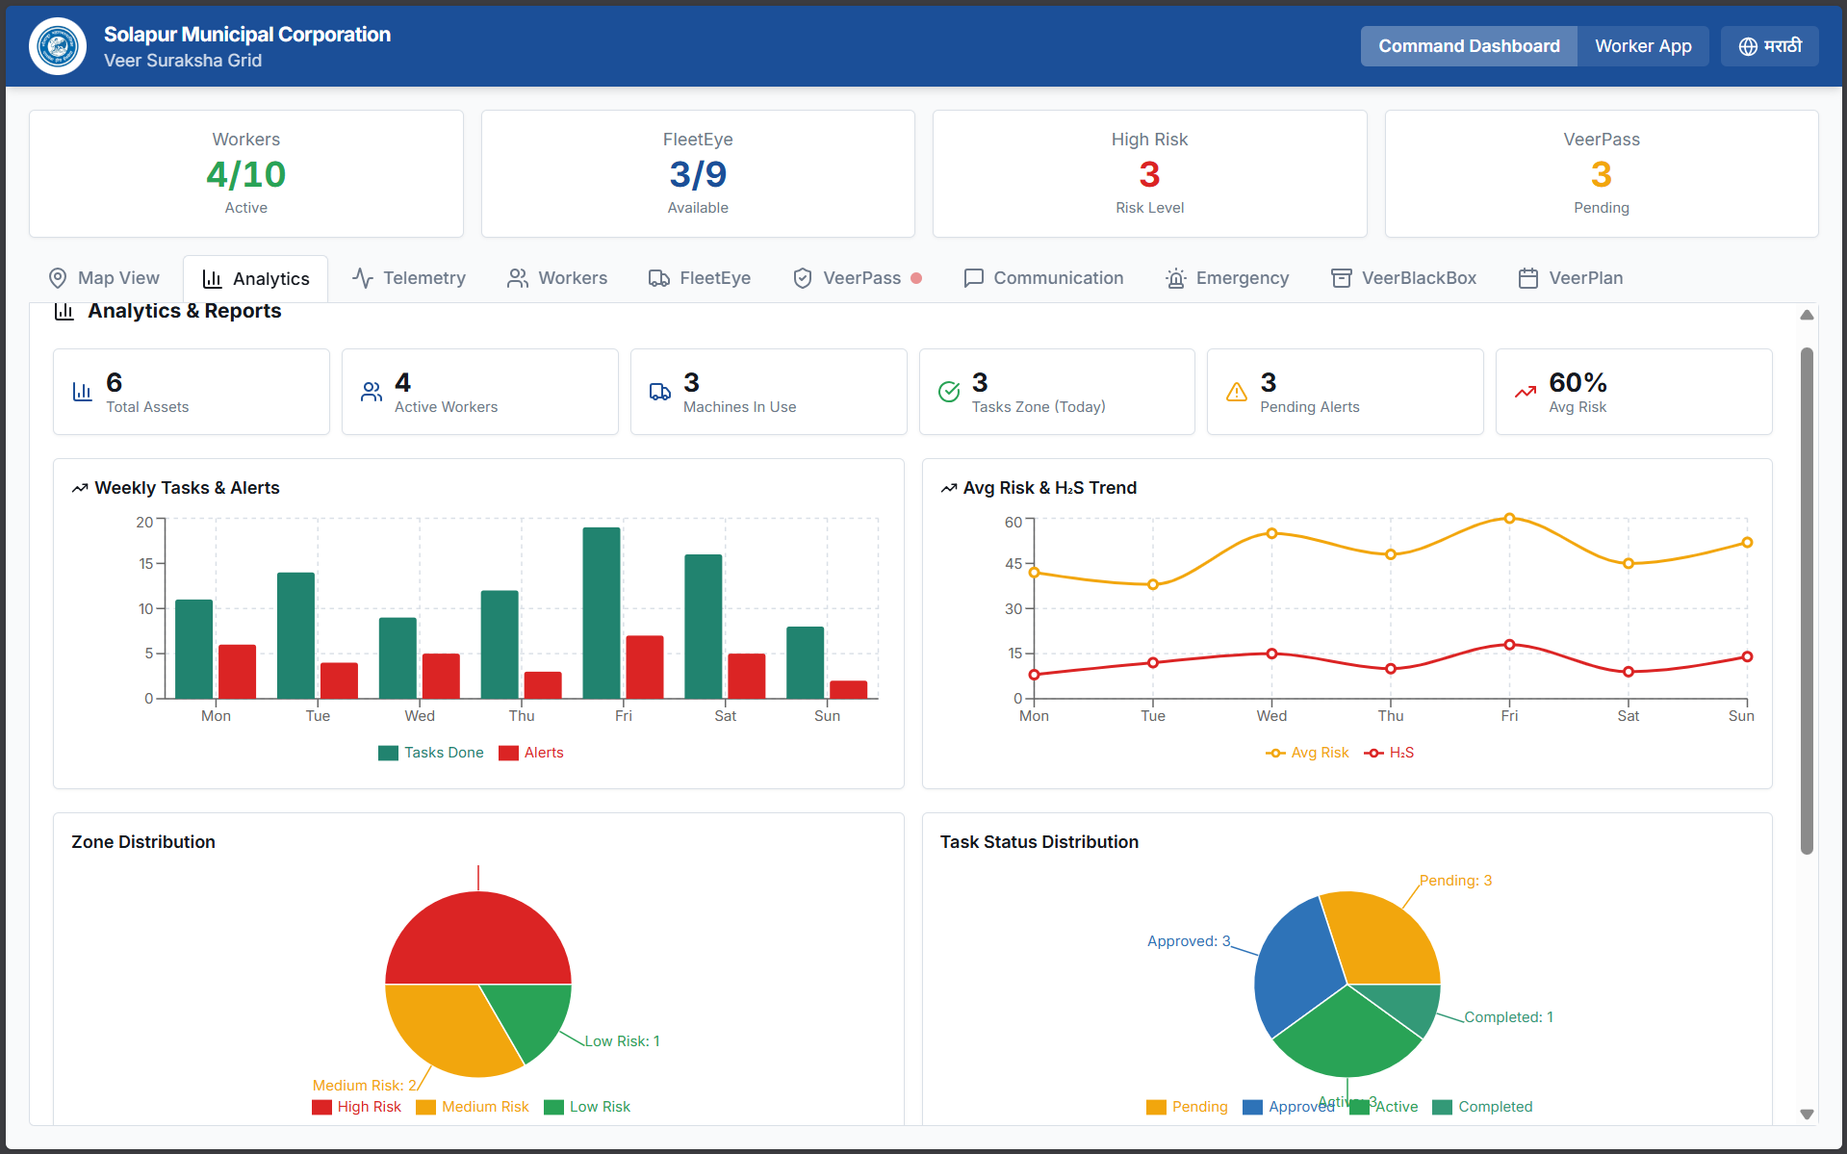
10.1 : Admin Dashboard
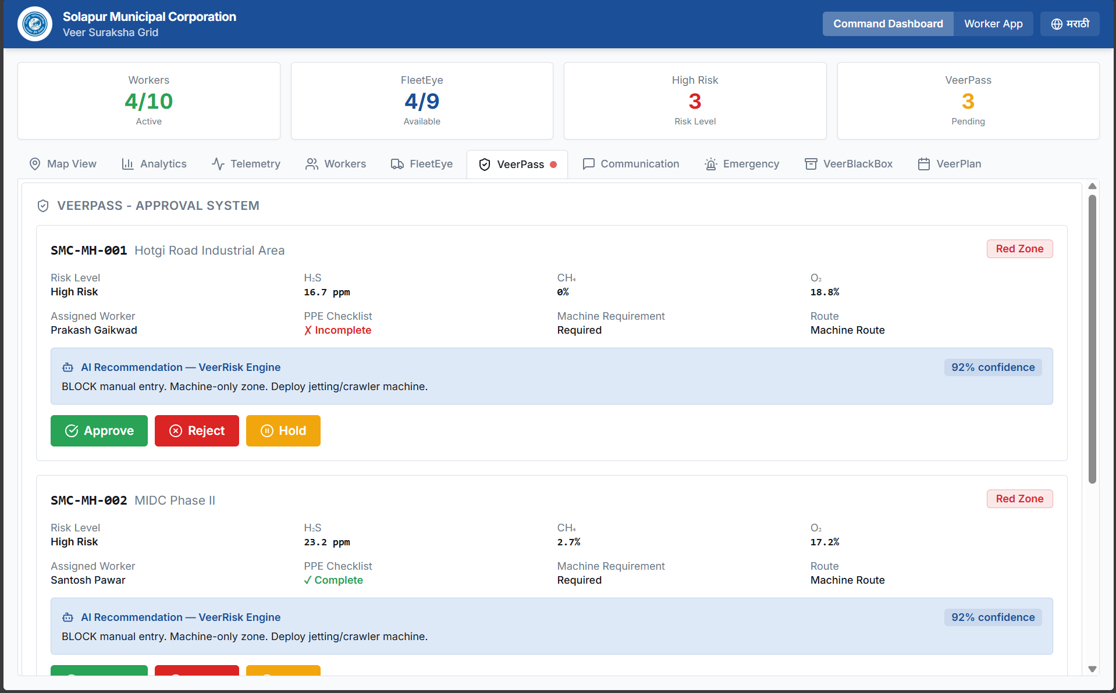
10.2 : Admin VeerPass (in action)
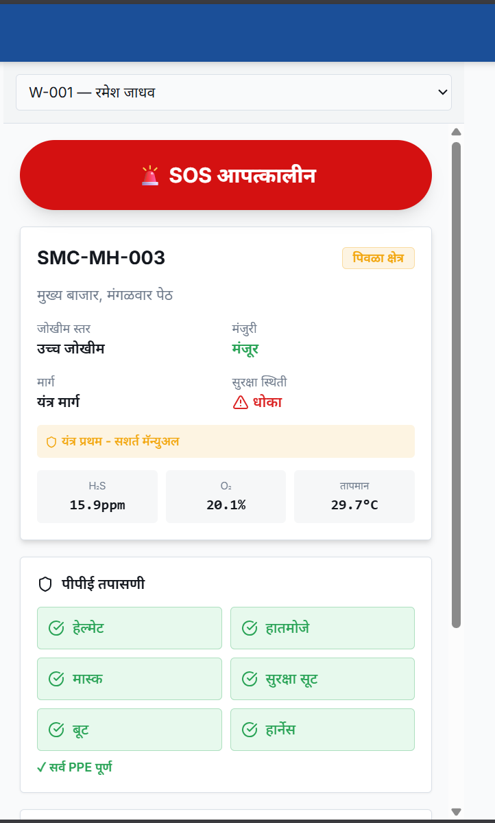
10.3 : Swachhata Veer Interface
- Reproducibility & Code Access

- GitHub Link : tusharkkp/Veer-Suraksha-Grid

- Prototype Link : https://veer-suraksha-grid.netlify.app/

- Drive Link : SAMVED WORK DRIVE

- Steps to run the system :
- Clone or download the complete project source code.
- Install frontend dependencies.
- Install backend dependencies.
- Configure Firebase project credentials and collections.
- Configure InfluxDB Cloud bucket, token, org, and endpoint.
- Set environment variables for frontend and backend.
- Set up the IoT/device-side code for VeerGuard, VeerProbe, and VeerCrawler data flow.
- Connect the IoT/device layer with InfluxDB Cloud for live telemetry push.
- Start the backend server.
- Start the frontend application.
- Open the web platform in a browser.
- Log in through the two user roles: Worker / स्वच्छता वीर and Commander/Admin.
- Create or load a task linked to one of the six mapped sewer assets.
- Verify live telemetry, machine status, approval workflow, communication flow, and SOS trigger workflow.
- Check logs, incident records, and dashboard outputs for successful demonstration.

- Dependencies / requirements:
- Node.js and npm
- Frontend packages
- Backend packages
- Firebase project setup
- InfluxDB Cloud setup
- Environment variable configuration
- IoT/device-side codebase
- Sensor/device integration setup for VeerGuard, VeerProbe, and VeerCrawler
- Internet connection for cloud services
- Modern web browser
- Git/GitHub for version control
- Map integration support for Solapur asset view

- SMC Impact Assessment (Proposed)

Sr No. | Impact Area | Current State | Proposed Improvement | Expected Benefit
1 | Worker Safety | Safety checks are fragmented and hazard visibility is limited during sewer operations | Real-time monitoring, pre-entry inspection, digital approval, and SOS workflow | Reduced unsafe exposure and faster emergency response
2 | Machine Utilization | Machines exist but may not be consistently enforced before manual fallback | FleetEye and machine-first workflow check machine availability and suitability before entry | Better machine usage and reduced unnecessary manual entry
3 | Approval & Accountability | Manual entry decisions may depend on informal field judgment | VeerPass creates a digital approval workflow with traceable decision records | Stronger governance, transparency, and auditability
4 | Operational Visibility | Worker status, asset status, and field events are not available in one unified view | SwachhCommander dashboard provides map-based live monitoring of assets, workers, tasks, and machines | Better command control and faster decision-making
5 | Emergency Handling | Emergency response is more reactive and less digitally coordinated | Worker SOS, admin alerts, and medical escalation workflow are integrated into the platform | Faster response during distress situations
6 | Planning & Maintenance | Work is more complaint-driven than preventive | VeerPlan supports risk-based and preventive planning using asset and task history | Improved maintenance planning and reduced recurring risk
7 | Complaint-to-Action Flow | Complaint handling and field execution are not tightly linked to safety workflow | Grievance integration connects complaint input with asset mapping, risk review, and task flow | Better service coordination and citizen response quality
8 | Field Communication | Worker-admin communication is limited or outside one integrated system | Built-in two-way communication between worker and Commander/Admin | Faster coordination and better field support
9 | Municipal Adoptability | Existing systems are fragmented across monitoring, complaint handling, and supervision | One connected Marathi-first platform aligned to SMC workflow | Easier adoption, higher efficiency, and stronger institutional control

- Limitations & Future Scope

Current Limitations
- The current prototype is limited to a pilot-scale model with 6 sewer/manhole assets and 10 workers.
- The present system demonstrates workflow logic, but full city-wide deployment and real municipal integration we need to coordinate with SMC.
- The IoT layer still has real-world hardware challenges such as waterproofing, corrosion resistance, gas-safe enclosure design, shock protection, and rugged field durability for sewer conditions.
- Sensor systems may require calibration, maintenance, battery management, and periodic validation for dependable field performance.
- AI support in VeerVision and VeerPass is currently decision-assistive, not fully autonomous.
- Emergency escalation is demonstrated as a workflow and not yet connected to actual ambulance or paramedic systems.

Assumptions Made
- Solapur is divided into operational risk zones such as high-risk, medium-risk, and low-risk areas.
- Machine inventory, asset distribution, and some field conditions are based on assumed prototype values.
- Suitable machine types such as jetting, rodding, sludging, and robotic units are assumed to be available in trackable inventory.
- Workers, assets, approvals, and communication records are assumed to be digitally manageable through the platform.
- Field device data for VeerGuard, VeerProbe, and VeerCrawler is assumed to be available to the system for monitoring and decision-making.
- Commander/Admin is treated as a merged operational role for prototype simplicity.

Possible Future Improvements
- Expand from the 6-asset pilot model to city-wide Solapur deployment.
- Integrate with actual field hardware and live sensor devices for continuous deployment use.
- Connect with real municipal grievance systems, ICCC systems, GIS layers, and emergency services.
- Add stronger AI models for hazard prediction, anomaly detection, and approval recommendation.
- Improve FleetEye with predictive maintenance and deeper machine allocation optimization.
- Add multilingual expansion, offline support, and stronger mobile usability for field adoption.
- Extend VeerPlan for long-term preventive maintenance analytics and recurring-risk prediction.

Team Information
Team name: Aarohan |  |  | Institute code: 06146
Institute name: MIT Academy of Engineering, Alandi, Pune
City: Pune |  |  | State: Maharastra
Team Leader Information
Leader name: Tushar Kalyanrao Kaldate
Contact number: 7798760700 |  |  | Email: tusharkaldate110@gmail.com
Mentor Details
Mentor name: Mr. Amar H More
Contact number: +91 98509 78452 |  |  | Email: ahmore@comp.maepune.ac.in
Participant Details
SN | Participant name | Program | Sem | Contact number | Email
1 | Tushar Kaldate | Computer | 4th | 7798760700 | tusharkaldate110@gmail.com
2 | Shreyas Salunkhe | Computer | 4th | +91 832 923 1523 | Shreyassalunkhe811@gmail.com
3 | Pranshu Bobade | Computer | 4th | +91 89830 74636 | pranshubobade@gmail.com
4 | Aradhya Avhad | Computer | 4th | +91 80070 26587 | avhadaradhya@gmail.com
5 | Sheel Gaikwad | Computer | 4th | +91 70575 34508 | gaikwadsheel@gmail.com

Declaration
We hereby declare that the work titled “Smart Safety and Assistance System for Sanitation Workers of Solapur Municipal Corporation” submitted for SAMVED-2026 is the original outcome of our team’s efforts. The work has been carried out by us under the guidance of the undersigned mentor and is neither copied from any source nor generated using artificial intelligence (AI) tools.
Place: Pune
Date: 21/03/2026
Team Leader Name: Tushar Kaldate
Mentor Name: Mr. Amar H More

